CPSC 425 Assignment 4 （due November 14, 2018）

Quan Zhang

48486154

3 def match(image1,image2), in which image1 and image2 should be 2 images that have some common items but with different size and angle. We improve this function so that it identifies and displays correct matches by comparing the key point descriptor vectors. Print the box image showing the set of matches to the scene image for your suggested threshold value. Write a short description of the particular threshold value used.

Input: match('scene','basmati')

Output: figure(3.1)

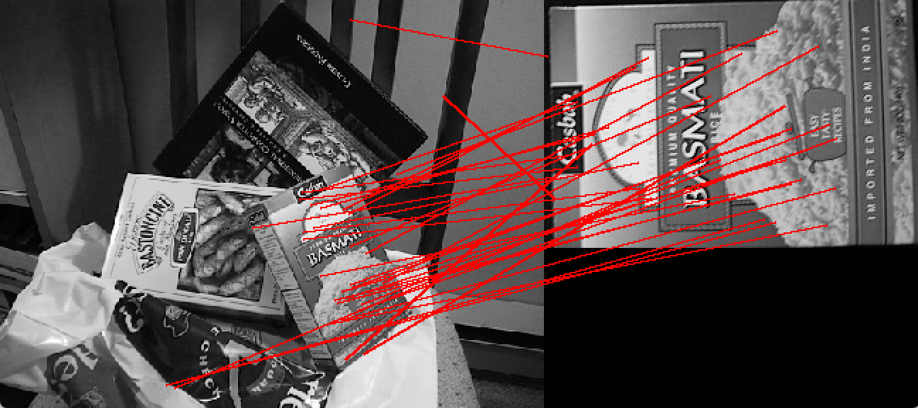

figure(3.1) match scene with basmati

Input: match('scene','book')

Output: figure(3.2)

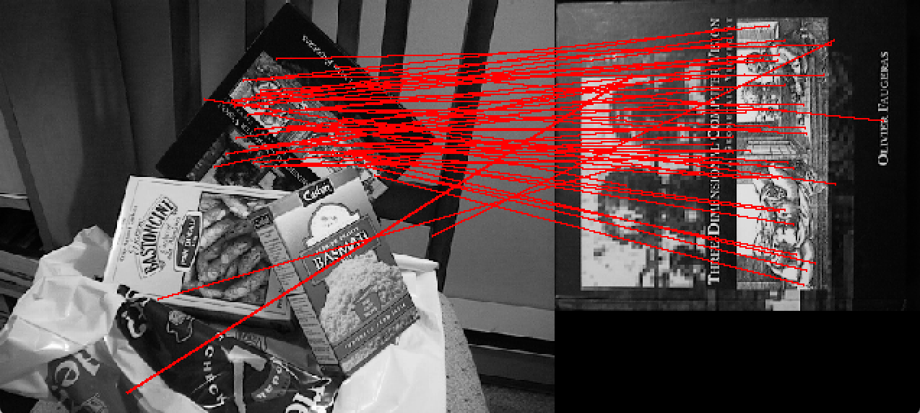

figure(3.2) match scene with book

Input: match('scene','box')

Output: figure(3.3)

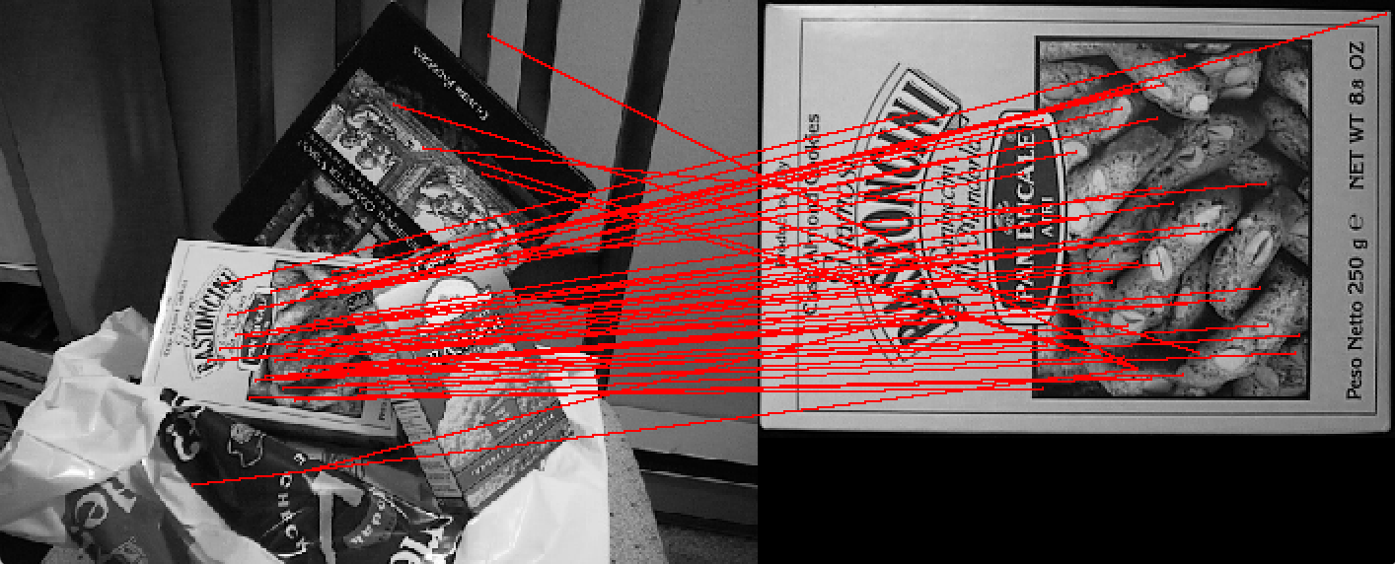

figure(3.3) match scene with box

I select the threshold value of 0.76 because it produces substantial number of matching lines and only a maximum of 7 outliers are found that had a noticeably different angle.

It is important to choose a good value for this threshold. If we select a too big threshold, we will risk missing correct matches (false negatives). But if we select a too small threshold, we will get too many invalid matches (false positives). Then the next step (RANSAC) will be unlikely to provide a feasible model fitting without a large number of samples. If we have more than 10 obvious outliers, RANSAC will probably use each of those ten as sample points to construct support sets which will clearly lead us to undesirable results. The probability of such undesirable results increases as our threshold decreases.

(implemented in file SIFTmatch.py as def match(image1, image2))

4 Reduce the number of false matches by using RANSAC. To check other matches for consistency with the first match, we use the keypoints1 and keypoints2 arrays that are provided for each image. Each row provides 4 numbers for a keypoint specifying its location, scale, and orientation in the original image (see the function ReadKeys in the file SIFTmatch.py for details).

I try different values for the orientation and scale agreement, and raise the matching threshold to get as many correct matches as possible while having only a few false matches. With angle agreement limit of 21 degrees, scale agreement limit of 0.9 and the largest support set size of 10, the largest threshold I can raise to, with as many correct matches as possible while having only a few false matches is 0.65.

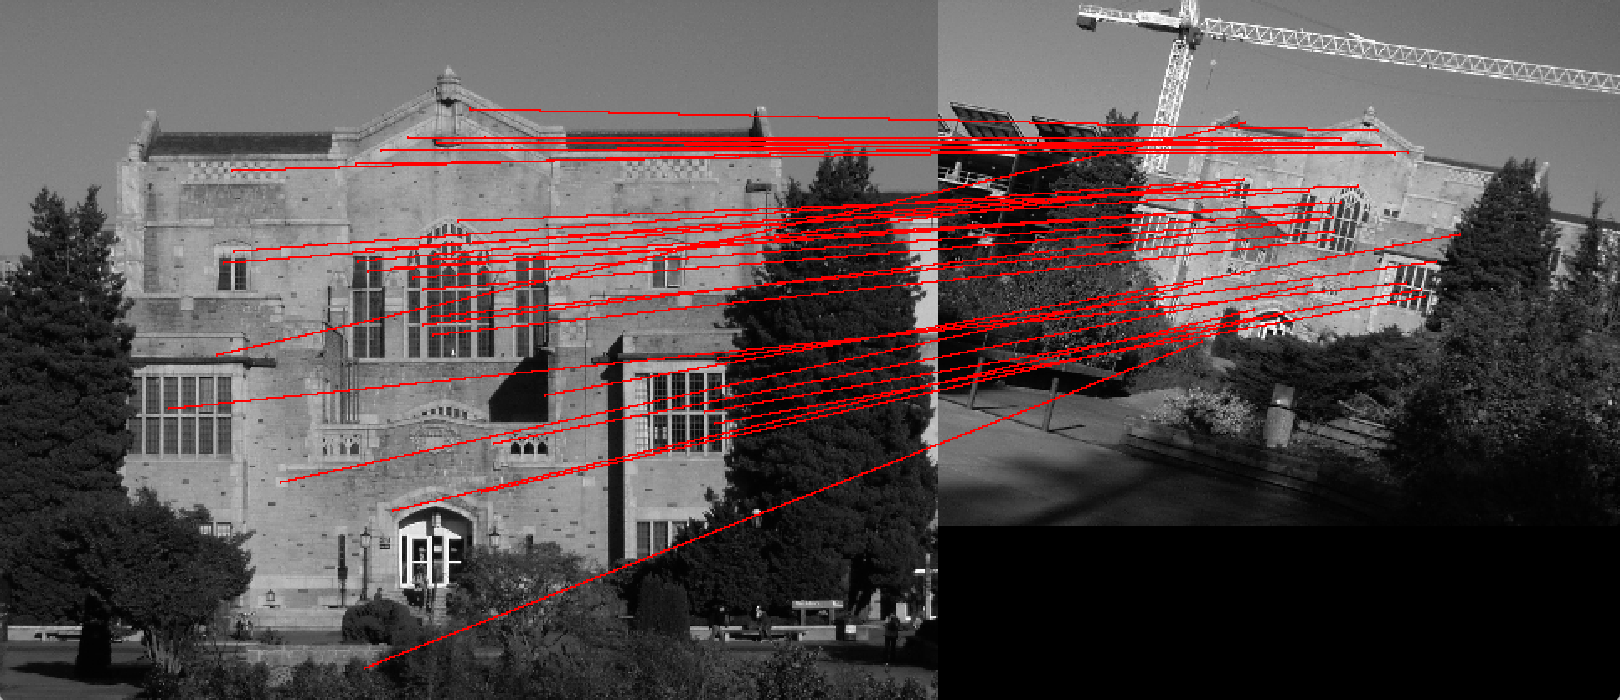

figure(4) threshold 0.65

We utilize consistency checking to compare the orientation (degree) and scale differences between matches. This gives us an effective way of measuring the compatibility between the matches we find. RANSAC enables us to increase the matching threshold because it will eliminate any matches that we have found in the previous step that are not in agreement with the largest support set we find. The final result is a set of matches that are in strong agreement with respect to degree, scale, and position.

(implemented in file SIFTmatch.py as def match(image1, image2))